An outline of our approach to assessment and reporting in Year 7, 8 and 9

A Quick Guide

08
Fall

2016
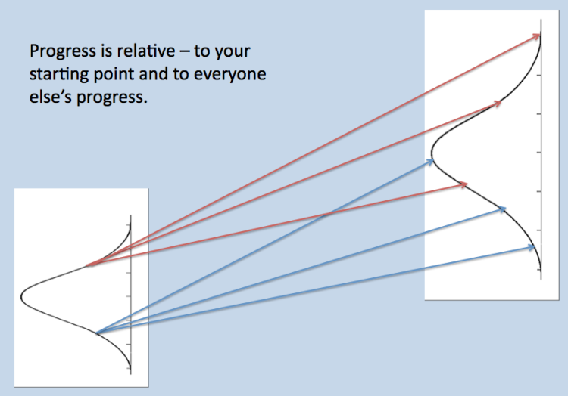

Highbury Grove School
Assessment at KS3
The Background
In 2014, the government removed National Curriculum Levels for Year 7, 8 and 9 (Key Stage 3). There were lots of technical problems with levels. Schools across the country have been working to develop new ways to assess progress and attainment at KS3 so that students and their parents know how well they are doing and how to improve.
Basic Principles:
Formative Assessment and Feedback.
The most important goal of assessment is that it helps students to make progress with their learning. Grades by themselves tell students how they compare to others but they don’t tell them anything about what they need to do to improve their work or deepen their understanding. They need feedback based on an assessment of their work.


Formative assessments in each subject are the most important part of our assessment system. We use tests, marking criteria and examples of excellent work to show students the standards that are expected and how to reach them. Feedback to students can guide them through the steps needed to improve. Austin’s Butterfly illustrates this idea: he gradually improved his drawing because he acted on the feedback he was given.
Progress
Every child arrives to Highbury Grove having reached a different level of attainment. It is important that we take account prior attainment in setting learning goals and measuring progress. In our system, Progress grades take account of how well each student is doing compared to where they started. All students have scope to make excellent progress regardless of where they start.
Attainment Standards.
All children should know that their learning has no limits; that they can continually improve and reach ever-higher standards. Standards in learning are often defined by comparing certain outcomes to the full range of outcomes from all students. ‘How good is my writing?’ or ‘is 70% a good score?’ are questions that are best answered by comparison with standards set by the cohort as a whole. So, as well as telling students how to improve and how much progress they are making, we believe it is important for everyone to know how their level of attainment fits into the pattern of achievement in the school and nationally. A simple way to do this is by using a grade scale.
We use the scale 1-9, linked to GCSE grades, so that it is familiar to everyone involved.
The Process
Every student has a target grade for each subject based on their KS2 Outcomes. These aspirational targets are generated by a system called FFT 20*. These targets are not used to label students; they sit in the background of our data system to help teacher’s award appropriate grades.

FFT 20 grade | Exceeding Target  Exceptional  Progress  E | Securely on Target  Good  Progress  G | Approaching  Target  Some  Progress  S | Below  Target  Poor  Progress  P
9 |  | 8 | 7 | 6
8 | 9 | 8 | 7 | 6
7 | 8 | 7 | 6 | 5
6 | 7 | 6 | 5 | 4
5 | 6 | 5 | 4 | 3
4 | 5 | 4 | 3 | 2
3 | 4 | 3 | 2 | 1
For reference to old GCSE grades: 9~A**, 8 ~A*, 7~A, 6~B, 5~C/B, 4~C, 3~D, 2~EFG
It is expected that the G grade is the default grade for students completing the work to a good standard routinely. E indicates pushing to the top edge of the grade range and will be reserved for genuine excellence; E means Exceptional. S meaning ‘Some’ suggests that, whilst progress is being made, it needs to improve to achieve excellence. We set high standards that may be challenging for some students but we think that is a good way to keep students focused on aiming high.
Although we are using discrete numbers 1-9, each number on the scale is indicative of a wide attainment range. Teachers are using their judgement based on assessments of different kinds to estimate the best-fit grade. As we get to know how the new GCSE grades work in practice, we will get better at making these estimates more accurately.
1
3
5
9
7
2
4
6
8

Very low attainment Average Attainment Very high attainment
Crucially, the numbers do not form a ladder; students making steady progress at the same rate, will retain the same grades throughout, every year. There is no limit on anyone’s progress or attainment; students who continually improve beyond the average rate of progress will see their grades rise.
Attitude to Learning and Behaviour grades will be given as before: E (Excellent) G (Good) S (Some Concerns) P (Poor). A student with Progress S may well have E for attitude. This would indicate that they are working very hard but are still finding it difficult to progress, given their starting point.

*FFT 20 is Fischer Family Trust 20, and means that our target grades are pitched at the top 20% of the national cohort.
Knowledge Organisers

In order to help students, parents and teachers keep on track of the learning in each unit of work, we have developed Knowledge Organisers for every subject. Parents should find that these are stuck in students’ books and folders.

Data Reports
Parents will receive regular data reports during the year.
 | Year 7 | Year 8 | Year 9
Attitude to learning report | Mid-October | Mid-October | Mid-October
Assessment Point 1 | Mid-March | Mid-February | Mid-December
Assessment Point 2 | End of June | Mid-July | End of July

An Assessment Point Data Report will include grades for Behaviour, Attitude to Learning, Attainment and Progress.

Attitude to Learning is graded E, G, S, and P defined as follows:
Excellent: Always tries hard and perseveres when they experience difficulties, seeks to achieve excellence in all that they do, participates fully in lessons, is well organised and produces homework to a very high standard; often goes beyond the minimum expected.

Good: Consistently works hard and produces work that meets the expected standards; participates well in class, is well organised and has a good homework record with very few omissions.

Some Concerns: Inconsistent in terms of the quality of work produced, concentration in class, completion of homework and general organization.

Poor: Regularly arrives to lessons without completed homework or the required equipment; does not concentrate well in lessons and often produces work below the standards they are capable of reaching.

